BLUE-HTB

Can save ip as host in /etc/hosts

vi /etc/hosts

10.10.10.40 blue.htb

Nmap scan

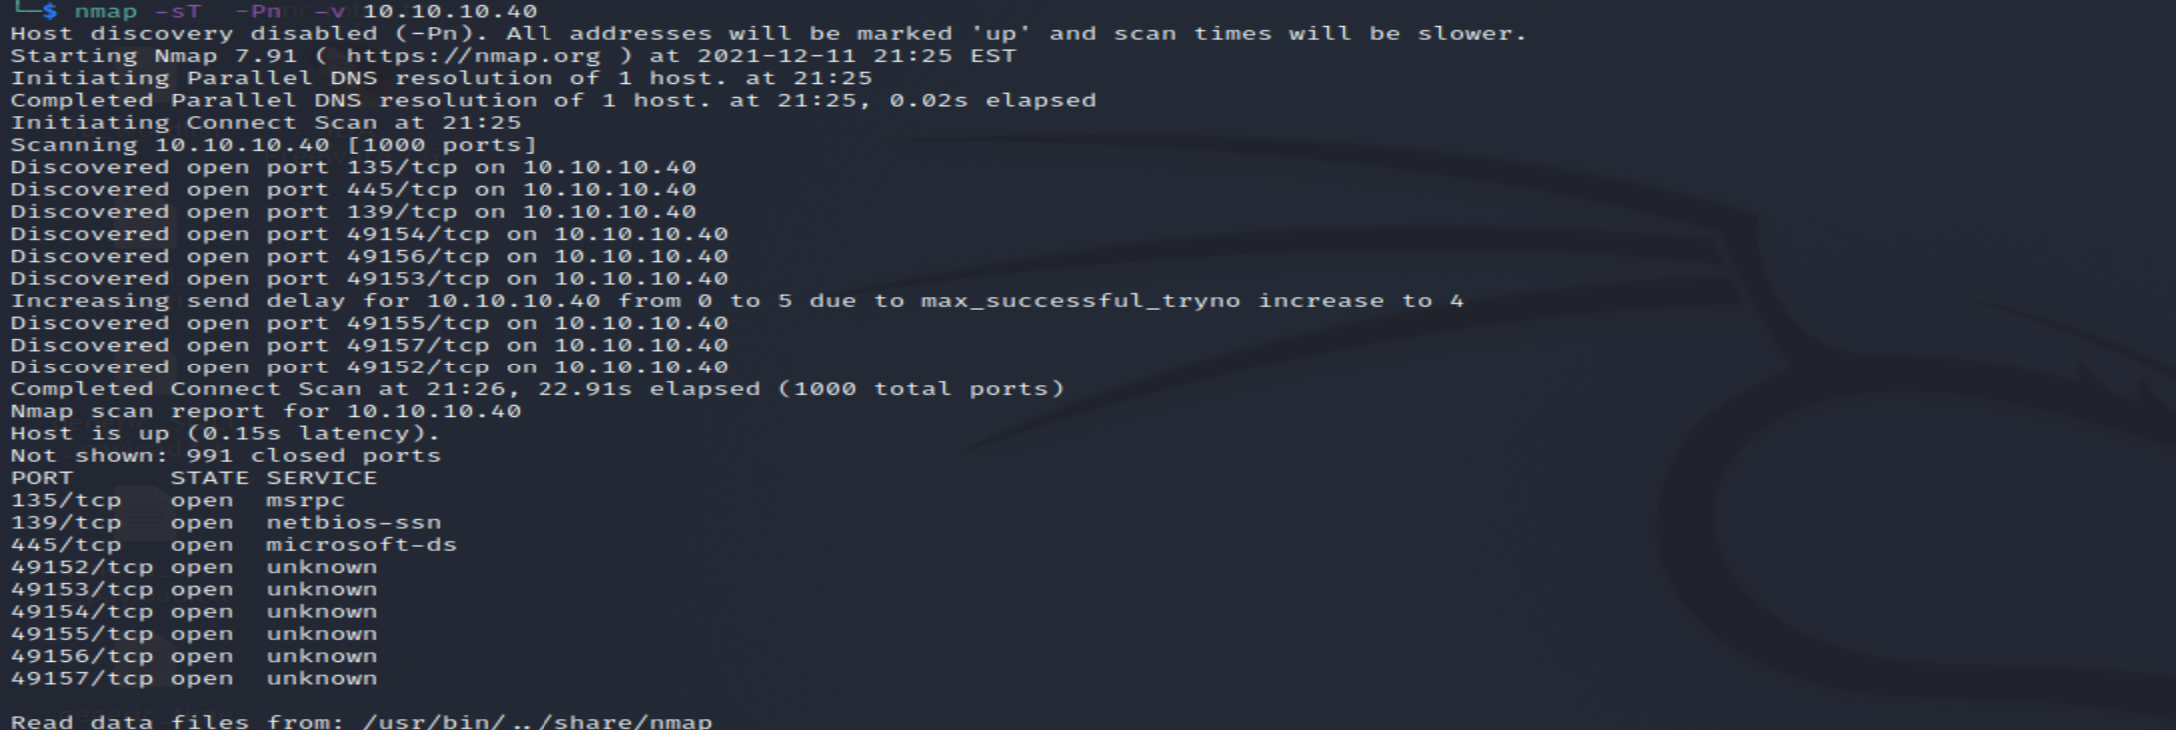

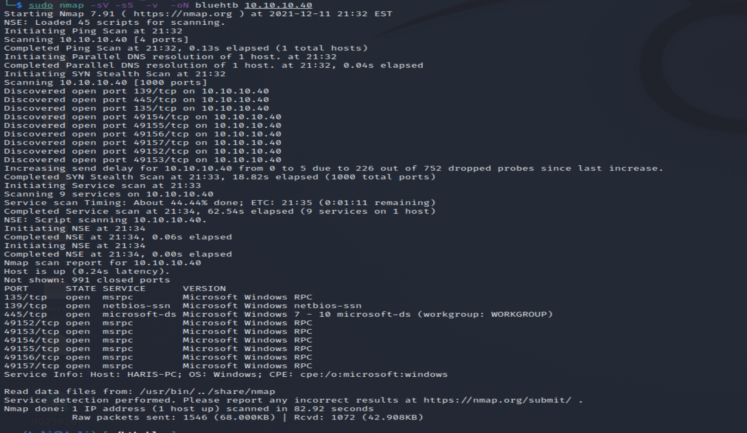

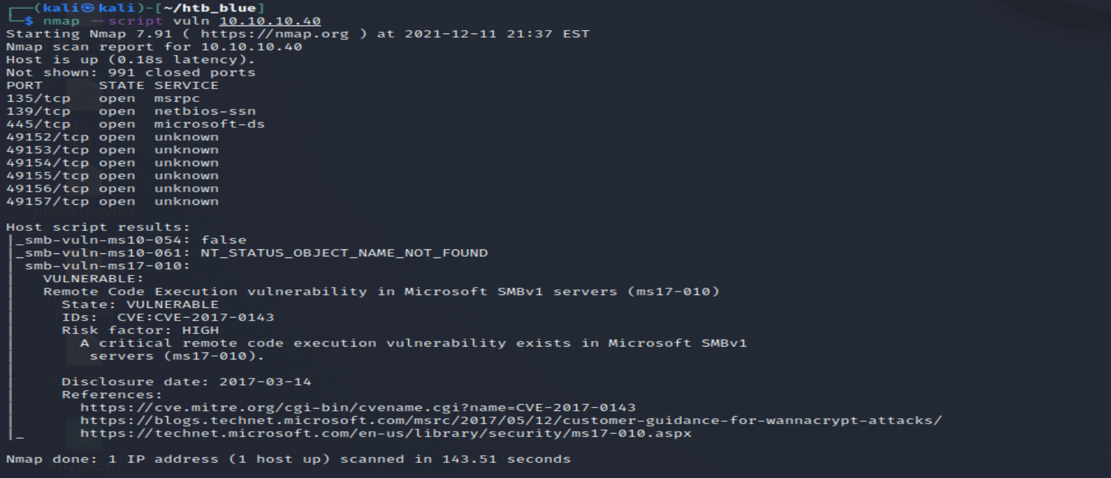

So as we have 445 a vulnerable port open so check for CVE ms17-010

Smb is vulnerable known as eternal blue became famous in 2017 with wannaCry.

2-msf

Msfconsole

Msf> search ms17-010

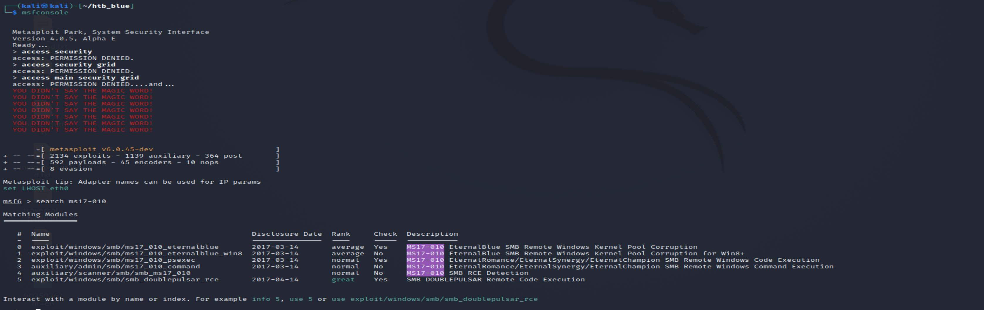

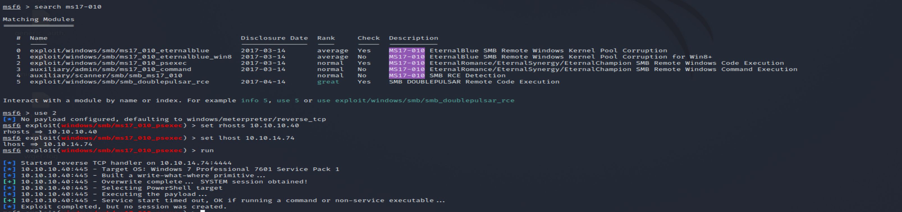

Msf exploit using vuln exploit

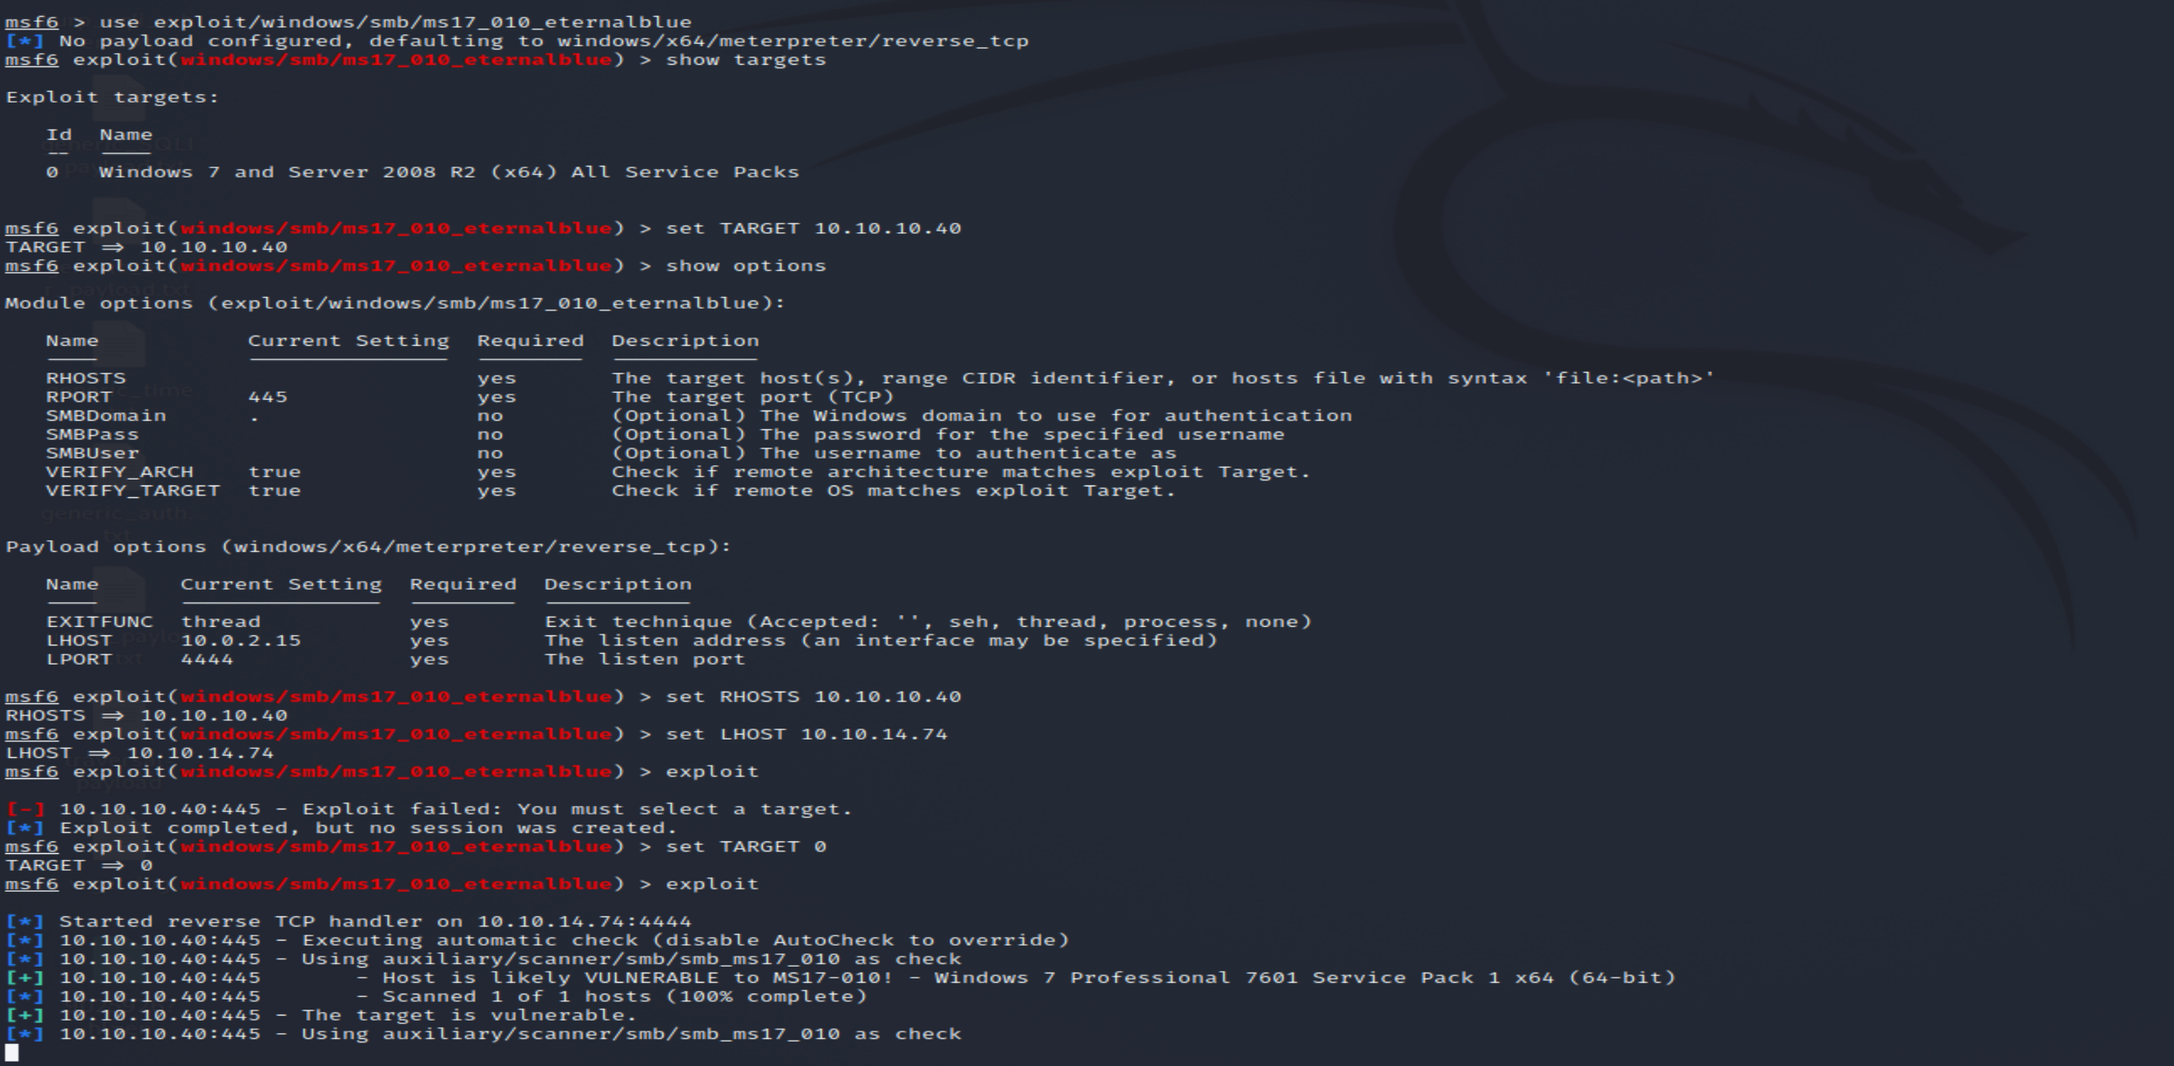

This might fail after triggering free of corrupted buffer. You should check for antivirus ,thus need evasion technique , Most like issue if using VM to test the exploit NAT , if machine running behind NAT then remote target system can be reached from you VM.Sol is to set bridged networking.

If antivirus really a problem obfuscation is key use msfvenom

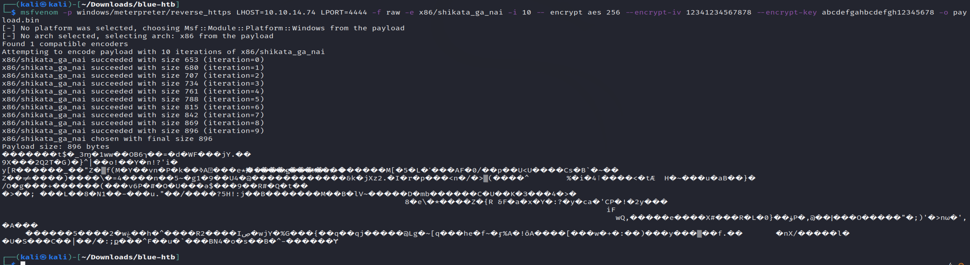

Else use msfconsole for setting enable stageencoding true and set stageencoder “vuln shellcode”

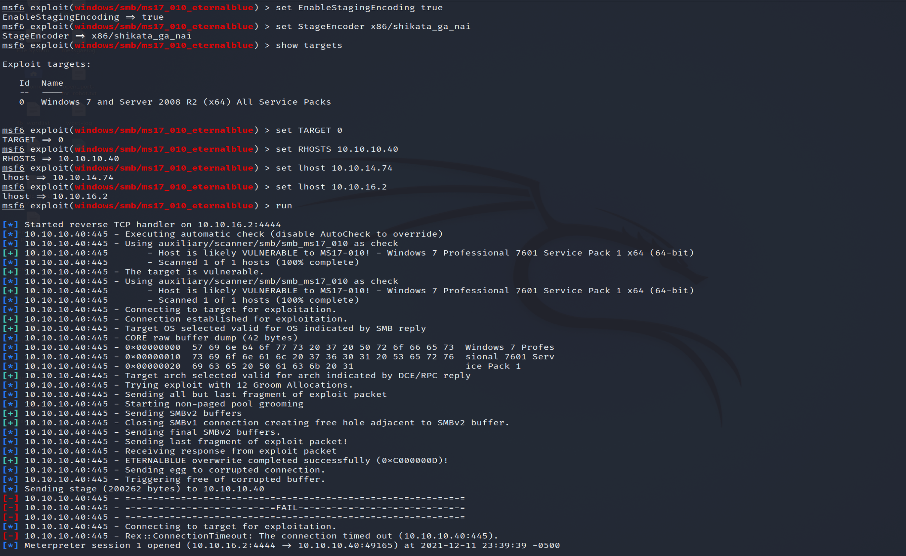

Network issue??